1.

(a)

(i)

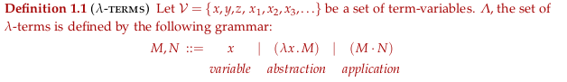

Beta-reduction rule: (lambda x.M)N ->Beta M[N/x]

(ii)

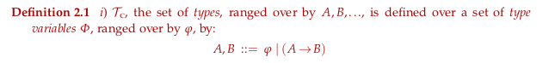

(iii)

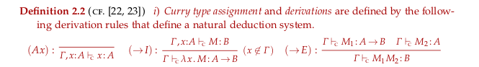

(b)



(c)

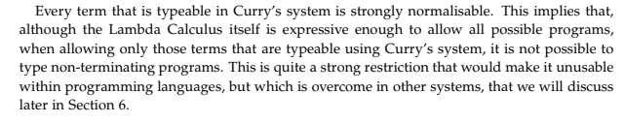

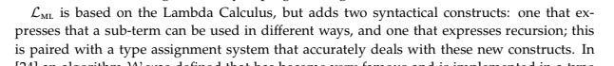

(d)

Exercise 2.23

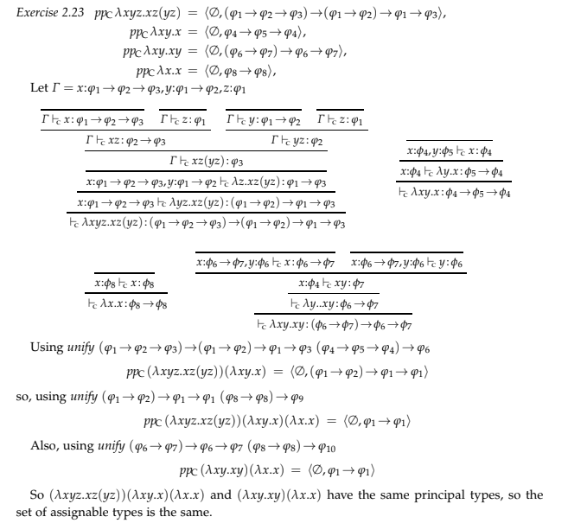

(e)

Exercise 2.20

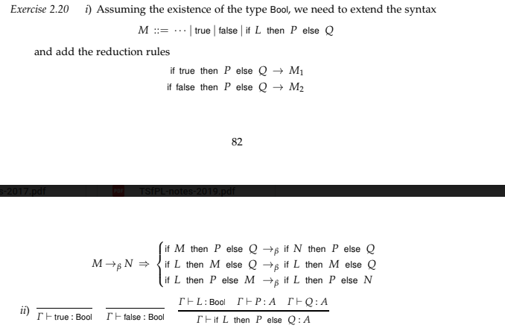

2.

(a)

(i)



(ii)

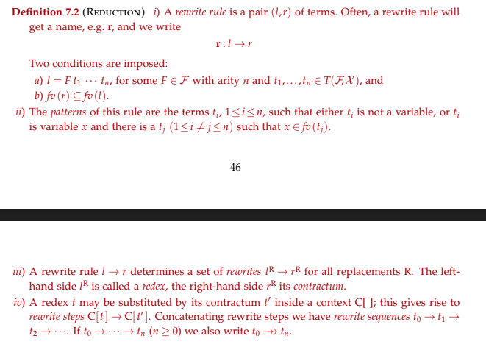

(iii)

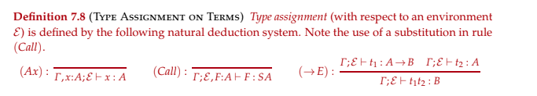

(b)

Exercise 4.6

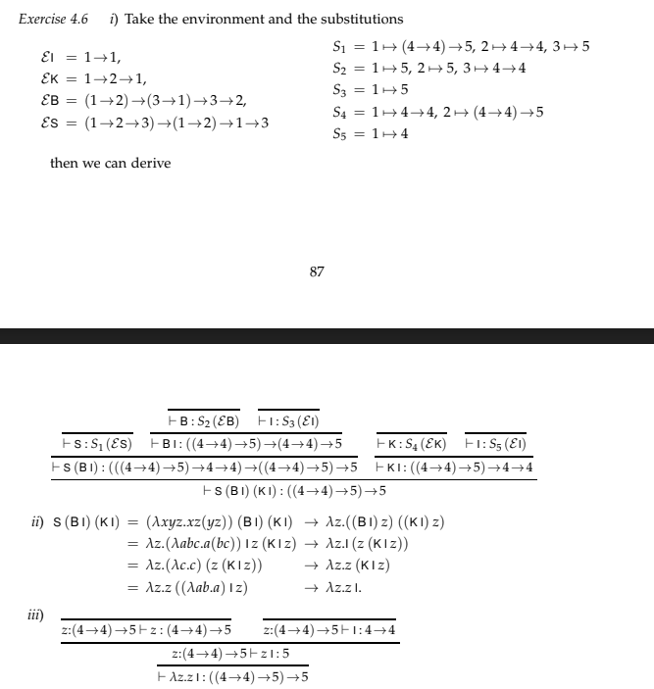

(c)

Exercise 7.22

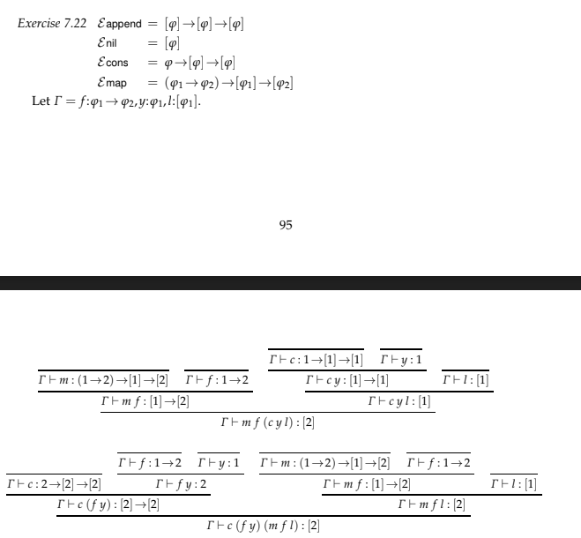

3.

(a)



(b)

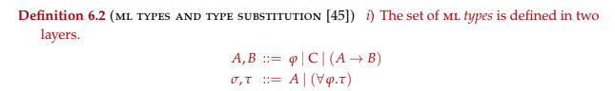

And def 6.4 for type assignment

(c)

Having recursive types?

(d)

Exercise 6.17 (6.18 in solutions)